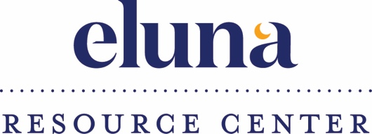

Job Title: Eluna Resource Center Clinical Intern or Volunteer
Employer: Eluna
Location Flexible: Seattle, WA with the ability to work remotely
Hours: Flexible schedule; Minimum 5 hours/week,
School Credit or Volunteer Hours
Reports To: Molly Sedlik Hasson, Director of Eluna Resource Center

Organization Summary:
Eluna is a public, 501(c)(3) non-profit organization with a mission to provide comfort, hope and healing to children and families affected by grief and addiction. Founded in 2000 by former MLB pitcher Jamie Moyer and child advocate Karen Phelps Moyer, Eluna supports thousands of children and families each year through its free signature programs and services. Camp Erin® is the largest national bereavement program for children and teens grieving the death of someone significant in their lives and Camp Mariposa® is a national addiction prevention and mentoring program for youth impacted by a family member's substance use disorder. The Eluna Resource Center extends our continuum of care by providing a curated set of online resources with personalized phone and email support for families experiencing grief, addiction and other related issues. For more information, please visit eluna.org.

Position Summary:
This internship or will provide opportunities for learning about the delivery of personalized care to families and children affected by grief. The Resource Center Intern will work the Director of the Resource Center to respond to individuals, care givers and organizations that reach out to Eluna for personalized resources. The Intern will also work to review current resources, research new resources and create custom online content.

Duties and Responsibilities:
- Research and develop resources for families impacted by grief and substance abuse disorder
- Prepare responses to individuals via email and phone within 24 hours
- Show compassion and care for the individuals that we serve
- Write case reports containing references, resources and referrals
- Enhance case report templates
- Work in Salesforce to record support case management
- Maintain and enhance case filing system
- Develop new custom content by writing summaries, reviewing literature and resources
- Build relationships with referral organizations

Background and Education Preferred:
  - Master’s or Bachelor’s level counseling related degree
  - Experience delivering social services to children and families

To Apply: Please send your resume and cover letter to Molly Hasson, Director of Eluna Resource Center. mollyhasson@elunanetwork.org

